**Example:**

**User1**

**User1**

**User1**

**..**

**User100**

**Profile1 : user1 – user20 : app1, app2**

**Profile2 : user21 – user70 : app1 , app3**

**Profile2 : user71 – user100 : app4, app5**

**Scenario: grant the access on app5 to user10**

**Control Access Using Permission Sets (Exception permission)**

You create a permission set to grant additional permissions to specific users who are organizing the conference. With a permission set, you can enable users’ access to conference app without changing their profile.

**Step 1: Create a Permission Set**

1. In Setup, click **Home**.
2. Enter Permission in the Quick Find box and select **Permission Sets**.
3. Click **New**, and create a **Permission Set** defined as follows.
   * Label: Conference App User
   * API Name: Conference_App_User
4. Leave all other fields as-is and click **Save**.

**Step 2: Add Permissions to the Permission Set**

1. In the Conference App User Permission Set Overview, click **Assigned Apps** in the **Apps** section. 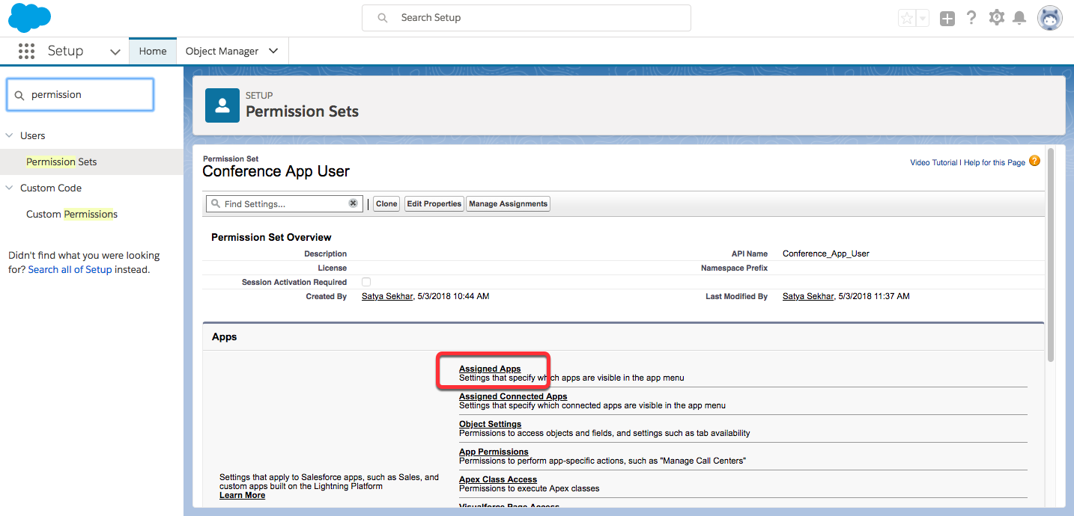
2. Click **Edit**.
3. Select **Conference** from Available Apps and click **Add**.
4. Click **Save**.
5. Enter Object Settings in Find Settings… and select **Object Settings**.
6. Click **Speakers** and click **Edit**.
7. Enable the following check boxes.
   * Tab Settings: **Available and Visible**
   * Object Permissions: **Read, Create, Edit and Delete**
   * Field Permissions: **Bio Edit Access, Email Edit Access, First Name Edit Access, Last Name Edit Access and Picture Path Edit Access**
8. Click **Save**.
9. Enter Object Settings in Find Settings… and select **Object Settings**.
10. Click **Sessions** and click **Edit**.
11. Enable the following check boxes:
    * Tab Settings: **Available and Visible**
    * Object Permissions: **Read, Create, Edit and Delete**
    * Field Permissions: **Description Edit Access, Level Edit Access and Session Date Edit Access**
12. Click **Save**.
13. Enter Object Settings in Find Settings… and select **Object Settings**.
14. Click **Session Speakers** and click **Edit**.
15. Enable the following check boxes:
    * Object Permissions: **Read, Create, Edit and Delete**
16. Click **Save**.

**Step 3: Create a User**

In this step, you create a user who uses the conference app. If there’s already an existing user, you may directly assign the permission set to that user as described in step 4.

1. In Setup, enter Users in the Quick Find box and select **Users.**
2. Click **New User**.
3. Enter the user’s name, email address, and a unique username in the form of an email address. By default, the username is the same as the email address.
4. Select the user license this user will have. Select **Salesforce**.
5. Select a profile, which specifies the user’s minimum permissions and access settings. Select **Standard User**.
6. Select the option to generate a new password and notify the user, click **Save**.

**Step 4: Assign Permission Set to the User**

1. In Setup, click **Home**.
2. Enter Permission in the Quick Find box and select **Permission Sets**.
3. Click **Conference App User**.
4. Click **Manage Assignments**.
5. Click **Add Assignments**.
6. Select the checkbox of the newly created user and click **Assign**.
7. Click **Done**.

Log in with the new user credentials and test the application. Kudos, you’ve granted additional permissions to a user using permission sets. You can revoke the permissions to the user any time by removing their permission set assignment using **Manage Assignments**.

1. From Setup, enter Permission Sets in the Quick Find box, then select **Permission Sets**.
2. Click **New**.
3. Enter your permission set information.
4. Select the types of users for the permission set.

When you create a permission set, you select a specific user or permission set license. If only users with one type of license can use the permission set, select the license that’s associated with the users. For example, to create a permission set for users with

* + the Salesforce license, select Salesforce. You can enable permissions only allowed in the Salesforce license.
  + the Identity Connect permission set license, select Identity Connect. You can enable permissions only allowed in the Identity Connect license.
  + different licenses, select **None**. Not selecting a specific license allows you to assign the permission set to any user whose license allows the permissions you enable in the permission set. For example, to assign the permission set to users with the Salesforce license and to users with the Salesforce Platform license, select **None**.

When creating a permission set for a specific permission set license, refer to that feature’s documentation. For example, to create a permission set for the Identity Connect permission set license, use these steps along with the Identity Connect documentation.

Permission set Assign to user

1. From Setup, enter Users in the Quick Find box, then select **Users**.
2. Select a user.
3. In the Permission Set Assignments related list, click **Edit Assignments**.
4. To assign a permission set, select it under Available Permission Sets and click **Add**. To remove a permission set assignment, select it under Enabled Permission Sets and click **Remove**.
5. Click **Save**.